Teammember:Yangyang, Zhiyong Zhou, Jing Ma

<Heart Rate Detector>

**Project Report**

First-year Hardware Project

School of ICT

Metropolia University of Applied Sciences

12 May 202

Abstract

|  |  |
| --- | --- |
| Author(s)  Title  Number of Pages  Date | Jing Ma Yang Yang Zhiyong Zhou  Heart Rate Detector  10 pages  12 May 2024 |
| Degree | Bachelor of Engineering |
| Degree Programme | Information Technology |
| Instructor(s) | Kimmo Sauren |
| This project is based on the technical support of the Hardware 2 course to design and produce a flexible and professional heart rate monitor. The purpose is to make group members proficient in this type of coding technology and apply relevant server and data processing skills. | |
| Keywords | Heart rate, HRV, Algorithm ,Kubios |

**Version history**

|  |  |  |  |
| --- | --- | --- | --- |
| **Ver** | **Description** | **Date** | **Author(s)** |
| 1.0 | Add device information and instructions and references | 17.4.2024 | Jing Ma |
| 1.1 | Add instruction and mid-summary of group work | 20.4.2024 | Yang Yang |
| 1.2 | Add figures | 06.5.2024 | Jing Ma |
| 1.3 | Add theoretical background | 08.5.2024 | Zhiyong Zhou |
| 2.0 | Added a section for group work summary | 11.5.2024 | Jing Ma |
|  |  |  |  |
|  |  |  |  |
|  |  |  |  |
|  |  |  |  |

**Contents**

[1 Introduction 1](#_Toc1921)

[Figure 1. Heart rate detector 1](#_Toc2376)

[2 Theoretical Background 2](#_Toc32031)

[3 Methods and Material 3](#_Toc31492)

[3.1 3](#_Toc26183)

[3.2 Sensor 4](#_Toc25116)

[3.3 OLED Display 4](#_Toc12399)

[3.4 Microcontroller: 5](#_Toc20461)

[4 Implementation 6](#_Toc26705)

[4.1 Algorithms 6](#_Toc12467)

[4.2 Functions of each part of the system 6](#_Toc23113)

[4.2.1 Measure heart rate locally. 6](#_Toc7454)

[4.2.2 HRV analysis 6](#_Toc8402)

[4.2.3 Kubios 7](#_Toc26377)

[4.2.4 History 7](#_Toc16031)

[5 Group Work Summary 8](#_Toc7836)

[5.1 Midway Summary 8](#_Toc23061)

[5.1.1 Yangyang 8](#_Toc9803)

[5.1.2 Zhiyong Zhou 8](#_Toc21237)

[5.1.3 Jing Ma 8](#_Toc12677)

[5.2 Final Summary 9](#_Toc24284)

[5.2.1 Yangyang 9](#_Toc22452)

[5.2.2 Zhiyong Zhou. 9](#_Toc5828)

[5.2.3 Majing 9](#_Toc6203)

[6 Conclusions 9](#_Toc26000)

[References 10](#_Toc8023)

# Introduction

In this project, the team designed and produced a portable Heart Rate Detector that can measure and analyze the user's heart rate data.

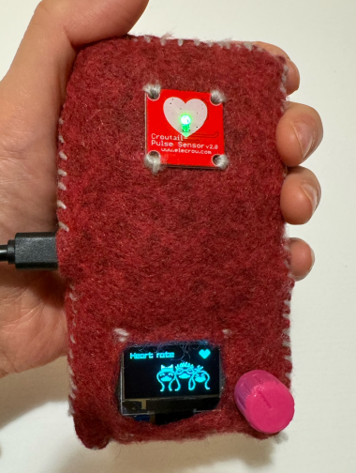

Figure 1. Heart rate detector

In modern society, the fast-paced work and life pressure have caused many people to suffer from sub-health or diseases. Many people also actively exercise in order to improve their health. Whether it is a negative or positive health condition, heart rate monitoring is an important reference indicator.

The device is suitable for use in a home or office environment and can be used by the end user themselves or by health and welfare professionals such as physiotherapists, nurses or doctors to bring professional reference data to those who need to monitor their heart rate.

After the team completes this project, they will know how to use the skills gained from the Hardware2 course. These functions are specifically broken down into:

– Use Micro-Python to program micro-controllers;

– Create wireless link between micro-controller and server;

– Familiar with sensors and other accessories related to micro-controllers;

– Familiar with how to read and interpret hardware device specifications;

– Familiar with micro-controller prototyping in health technology applications;

–Understand how to write algorithms to detect heart rate and its variability.

The team developing this project hopes to achieve the following goals:

1. Develop a heart rate detection algorithm that runs locally on the device;
2. Calculate heart rate variability (HRV) analysis;
3. Create a connection to the Kubios Cloud HRV analysis service to calculate more detailed HRV analysis;
4. Display estimated stress and recovery status index on the device.

# Theoretical Background

This project combines the use of specific sensors in the background of theoretical knowledge related to heart rate to achieve the purpose of measuring and analyzing heart rate data.

Heart rate (or pulse rate)[1.] is the frequency of the heartbeat measured by the number of heart contractions per minute (beats per minute or bpm). Heart rate varies based on the body's physical needs, including the need to absorb oxygen and expel carbon dioxide. It is also affected by many factors Modulations, including (but not limited to) genetics, physical health, stress or psychological state, diet, medications, hormonal status, environment, and disease, and the interactions between these factors.[2.] It is usually equal to or close to the pulse measured at any peripheral point.

Heart rate variability (HRV) is a physiological phenomenon in which the time interval between consecutive heartbeats varies from beat to beat. The magnitude of this change is small (measured in milliseconds). Heart rate variability in healthy individuals is greatest at rest, whereas HRV decreases during stress and physical activity. The magnitude of heart rate variability varies between individuals. HRV is the most commonly used tool to objectively assess physiological stress and recovery.

Heart rate shows the number of heartbeats in a minute, measured in beats per minute (bpm), while HRV shows the time between heartbeats, measured in milliseconds (ms).

Multiple physiological phenomena influence HRV, including: inspiration and expiration, respiratory control, autonomic nervous system (ANS) regulation, hormonal responses, and metabolic processes and energy expenditure.

People's heart rate ranges vary based on individual physical fitness. For example, the normal resting heart rate for adults is 60-100 bpm, but the resting heart rate for well-trained athletes is 37-38 bpm.[3.] There are also some common heart rate differences, such as tachycardia, a high heart rate defined as a resting heart rate above 100 bpm.[4.] While bradycardia is a low heart rate, defined as a resting heart rate of less than 60 bpm. When a person sleeps, it is normal for the heart rate to be around 40-50 bpm. When the heart doesn't beat regularly, this is called an arrhythmia. Abnormal heart rates sometimes indicate illness.

Photoplethysmography (PPG) signal. In the PPG signal, the position of the peak represents the moment when the heartbeat occurs. Therefore, the calculation of HRV requires accurately identifying the position of the peak value in the PPG signal, using A/D conversion to convert the signal, and then using a series of conversion procedures to accurately calculate the time interval between consecutive heartbeats to obtain professional heart rate and Heart rate variability data.

# Methods and Material

The project was carried out through a number of key sensors, screen devices, with associated calculation software to achieve the final measurement results and analyse the data. This part will introduce them one by one, which are Raspberry Pi Pico W. The combination of these hardware and software devices, together with the appropriate calculation procedures, will lead to the measurement and analysis results envisaged in the project.

## Raspberry Pi Pico

The device used in this project is the Raspberry Pi Pico, which contains eight components: USB cable, 3microbuttons, 3 LEDs, OLED Desplay, Rotary encoder and push button swich, Optical heart pulse detector, connectors for accessories, and Microcontroller with WIFI.

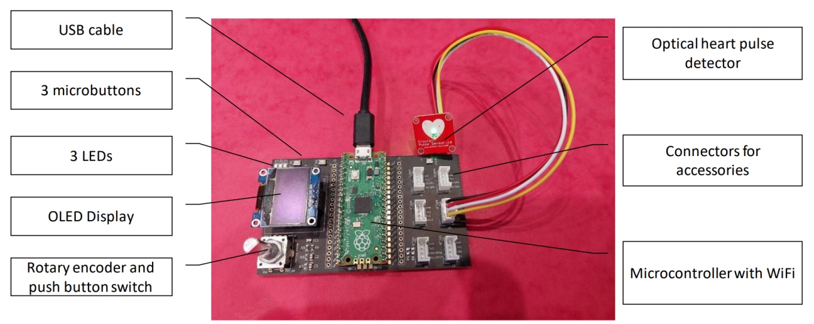

Figure 2. Raspberry Pi Pico

This part introduces the Optical heart pulse detector, OLED Display and Microcontroller.

## Sensor

Optical heart pulse detector, also known as a crow's tail pulse sensor. This is a 20 mm x 20 mm size, 3 to 5 V, analogue output, 609 NM wave length sensor.

The Pulse Sensor is a plug-and-play heart-rate sensor for Arduino. It can be used by students, artists, athletes, makers, and game & mobile developers who want to easily incorporate live heart-rate data into projects. It essentially combines a simple optical heart rate sensor with amplification and noise cancellation circuitry making it fast and easy to get reliable pulse readings. Also, it sips power with just 4mA current draw at 5V so it’s great for mobile applications.

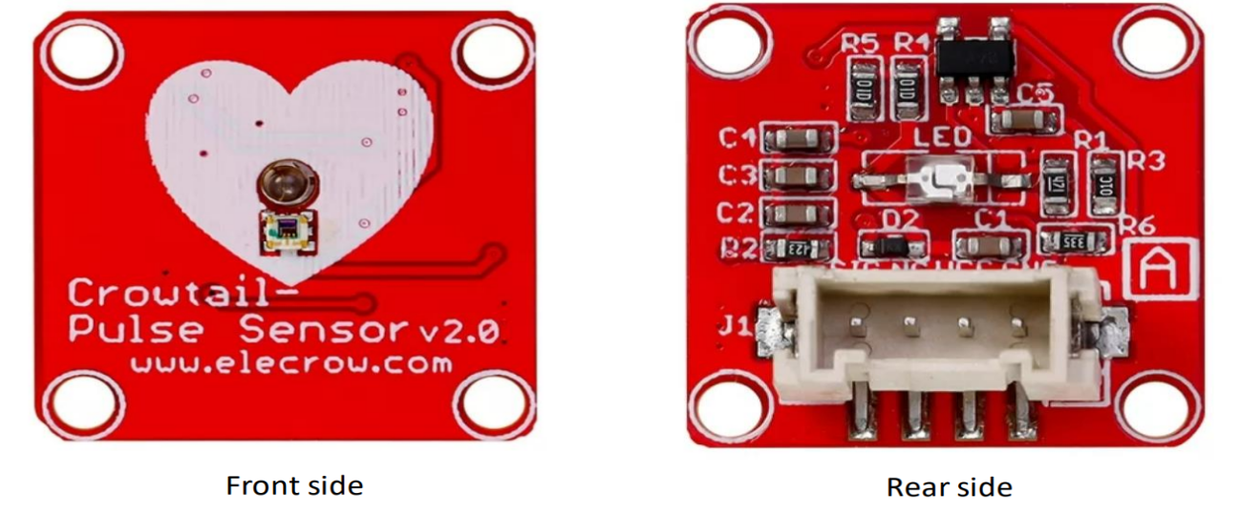

Figure 3. Optical heart pulse detector

## OLED Display

This OLED display module is small, only 0.96” diagonal, it is made of 128x64 individual blue OLED pixels, each one is turn on or off by the controller chip. This is a Raspberry Pi based heart rate variability monitoring system. It works without backlight, that is, in a dark environment, OLED display is higher compared to that of LCD display, and it has the miniature for its crispness. This module uses I2C to communicate with microcontroller such as Arduino.

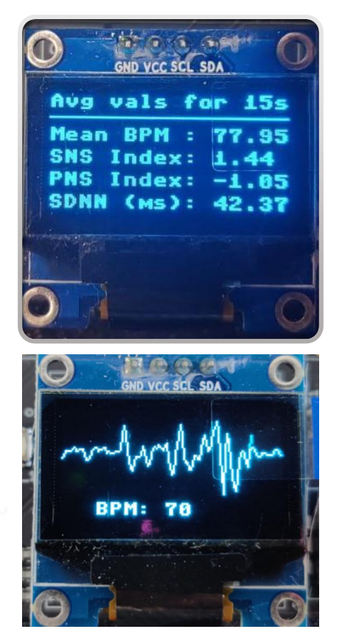

Figure 4. OLED display

## Microcontroller: Raspberry Pi Pico W

### Raspberry Pi Pico W is the RP2040 with wireless. the Raspberry Pi Pico W can use for physical computing projects. It can control anything from small electronics to LEDs and motors, read information from sensors, or communicate with other microcontrollers. This is a feature-rich microcontroller with two 32-bit ARM Cortex M0+ processor cores (dual core). Flexible clock, but configurable up to 133MHz max speed! This tiny MCU features up to 264 KB of SRAM, an external Quad-SPI of 2 MB, and Execute-In-Place (XIP). The large RAM and flash size enable you to write high-level programming languages such as MicroPython and CircuitPython for the Raspberry Pi Pico W.

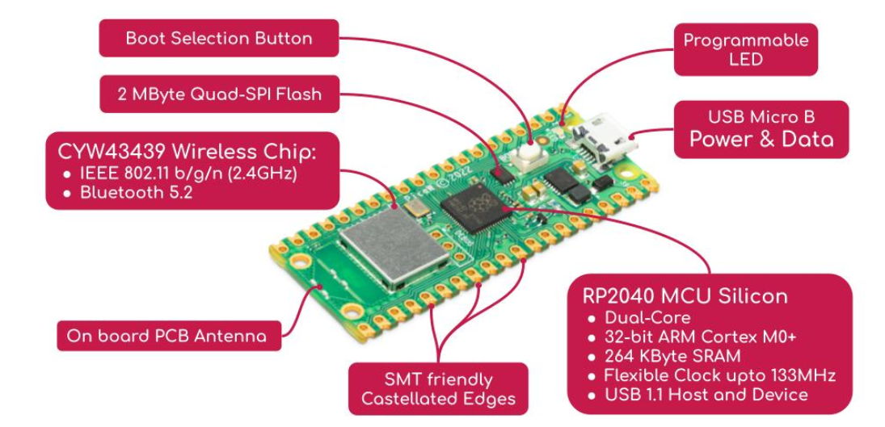

Figure 5. Raspberry Pi Pico W

# Implementation

## Algorithms: The developed algorithms used for calculating heart rate and heart rate variability.

## Heart rate and hrv algorithm 1. Find positive peak values: Get 2 seconds of data each time, about 500 signals, then get the maximum and minimum values ​​and calculate the average as the threshold. 500 data loops. Whenever the data is greater than the threshold, set a variable maxValue to get the value, if the subsequent signal is greater than maxValue, it will be overwritten until the signal value is less than the threshold, maxValue is the peak value, and so on. 2. When all positive peaks of 30 seconds are acquired, the time between peaks is obtained, that is, the number of samples between peaks \* 1/250s 3. After obtaining the positive peak interval time array, use the formula to calculate the heart rate and hrv values.

## Functions of each part of the system

This part mainly introduces the four functions of the heart rate meter.

### Measure heart rate locally.

Local heart rate data collection and heart rate measurement result generation can be achieved from the first function of the menu. As shown in Figure 6, after thirty seconds of collection, the device will generate the user's current heart rate.

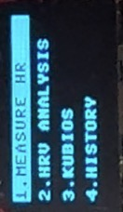 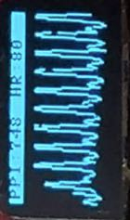 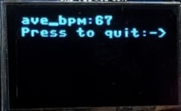

Figure 6. Measure HR

### HRV analysis

This function can calculate the user's heart rate variability based on the HRV algorithm, as shown in Figure 7. After measuring the current heart rate, the system will analyze the heart rate variability data and feed it back to the LED display.

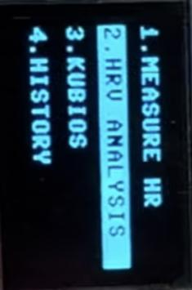 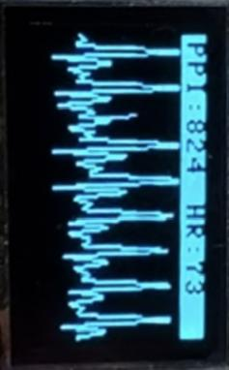 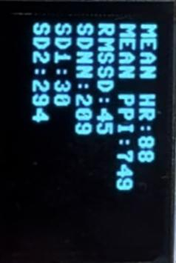

Figure 7. HRV analysis

### Kubios

In this function, the heart rate meter uses the official API of kubios to fill in the corresponding data, then passes the PPI array to the API, finally obtains the calculation result, and encapsulates the result into the format required by the system. As shown in Figure 8, after the user selects the "KUBIOS" option in the menu, the product starts to measure the user's heart rate and transmits the collected data to the KUBIOS server through the network. After obtaining the analysis results, it returns to the device and The results are displayed on the LED screen for user reference.

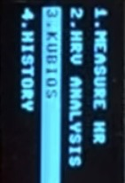 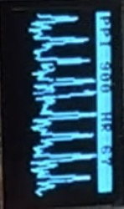 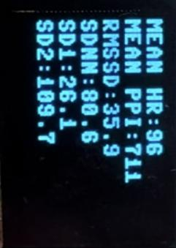

Figure 8. KUBIOS functions and results feedback

### History

This heart rate meter can store the user's historical measurement data, but in order to facilitate the user's reading, as shown in Figure 9, the system only retains the last 5 measurement data.

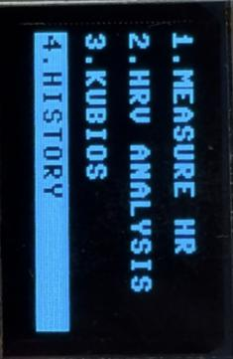 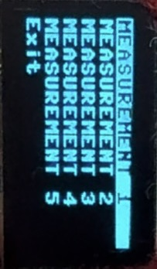

Figure 9. KUBIOS functions and results feedback

# Group Work Summary

This section presents a summary of the work done by each team member during the project. It will be divided into two summaries: one at the midpoint of the project and the other at the end of the project.

## Midway Summary

### Yangyang

As the leader of the project team, Yang Yang is responsible for the progress of the whole project, and secondly, he is responsible for the overall idea of programming as well as the construction of the main structure of the code together with Zhiyong.

### Zhiyong Zhou

Zhiyong is mainly responsible for the testing of the code and the cloud computing, which is related to the final smooth operation of the project.

### Jing Ma

Jing Ma is mainly responsible for writing project reports and part of the code, as well as planning and rehearsing project presentations.

## Final Summary

### Yangyang is mainly responsible for the conceptual design and structure construction of the project program, as well as the development of the main program and the management of the project process.

### Zhiyong Zhou takes care of testing the programs ,trouble shooting and developing the calculation part. At the same time, he also helped other teammates solve the difficulties and questions they encountered in the process of writing code.

### Majing is responsible for the coding of the display part, the design of the startup screen and transition screen, the design and production of product appearance, the editing of video content and the production of effects.

# Conclusions

During the completion of this project, the team members completed the design and programming of the heart rate monitor through very smooth communication and collaboration, and finally got a very portable, novel and unique appearance, rich in functions, and clear logic. And the calculation results are very efficient and accurate heart rate meter. In the process of writing code, the team members consolidated the various skills and knowledge learned through Hardware 2, implemented various functions as required, and also gained a lot of hardware programming inspiration in the process.

References

1 ["What is a normal pulse rate? - Heart Matters magazine - BHF"](https://www.bhf.org.uk/informationsupport/heart-matters-magazine/medical/ask-the-experts/pulse-rate). <https://www.bhf.org.uk/informationsupport/heart-matters-magazine/medical/ask-the-experts/pulse-rate>

2 [Jump up to:a](https://en.wikipedia.org/wiki/Heart_rate" \l "cite_ref-pmid19022405_2-0) [b](https://en.wikipedia.org/wiki/Heart_rate" \l "cite_ref-pmid19022405_2-1) [c](https://en.wikipedia.org/wiki/Heart_rate" \l "cite_ref-pmid19022405_2-2) Zhang GQ, Zhang W (2009). "Heart rate, lifespan, and mortality risk". Ageing Research Reviews. 8 (1): 52–60. [doi](https://en.wikipedia.org/wiki/Doi_(identifier)" \o "Doi (identifier)):[10.1016/j.arr.2008.10.001](https://doi.org/10.1016/j.arr.2008.10.001). <https://www.sciencedirect.com/science/article/abs/pii/S1568163708000524?via%3Dihub> [PMID](https://en.wikipedia.org/wiki/PMID_(identifier)" \o "PMID (identifier)) <https://en.wikipedia.org/wiki/PubMed#PubMed_identifier> [19022405](https://pubmed.ncbi.nlm.nih.gov/19022405). <https://pubmed.ncbi.nlm.nih.gov/19022405/> [S2CID](https://en.wikipedia.org/wiki/S2CID_(identifier)" \o "S2CID (identifier)) <https://en.wikipedia.org/wiki/Semantic_Scholar#S2CID> [23482241](https://api.semanticscholar.org/CorpusID:23482241). <https://www.semanticscholar.org/paper/Heart-rate%2C-lifespan%2C-and-mortality-risk-Zhang-Zhang/0ba98846db474ce32a32a0feaf7580ec7842b8e3>

3  [Jump up to:a](https://en.wikipedia.org/wiki/Heart_rate" \l "cite_ref-aha_rest_3-0) [b](https://en.wikipedia.org/wiki/Heart_rate" \l "cite_ref-aha_rest_3-1) ["All About Heart Rate (Pulse)"](https://www.heart.org/HEARTORG/Conditions/HighBloodPressure/GettheFactsAboutHighBloodPressure/All-About-Heart-Rate-Pulse_UCM_438850_Article.jsp). <https://www.heart.org/en> All About Heart Rate (Pulse). American Heart Association. 22 Aug 2017. Retrieved 25 Jan 2018.

4  ["Tachycardia| Fast Heart Rate"](http://www.heart.org/HEARTORG/Conditions/Arrhythmia/AboutArrhythmia/Tachycardia_UCM_302018_Article.jsp). <https://www.heart.org/en> Tachycardia. American Heart Association. 2 May 2013. Retrieved 21 May 2014.